Polynomial Regression in Python:
.
Step 1: Import libraries and dataset
Import the important libraries and the dataset we are using to perform Polynomial Regression.

# Importing the libraries
import numpy as np
import matplotlib.pyplot as plt
import pandas as pd

# Importing the dataset
datas = pd.read_csv('data.csv')
datas

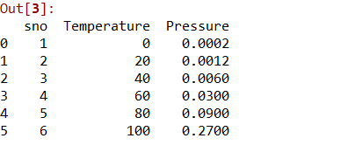
Step 2: Dividing the dataset into 2 components
Divide dataset into two components that is X and y.X will contain the Column between 1 and 2. y will contain the 2 column.

X = datas.iloc[:, 1:2].values
y = datas.iloc[:, 2].values
Step 3: Fitting Linear Regression to the dataset
Fitting the linear Regression model On two components.
# Fitting Linear Regression to the dataset
from sklearn.linear_model import LinearRegression
lin = LinearRegression()

lin.fit(X, y)

Step 4: Fitting Polynomial Regression to the dataset
Fitting the Polynomial Regression model on two components X and y.
# Fitting Polynomial Regression to the dataset
from sklearn.preprocessing import PolynomialFeatures

poly = PolynomialFeatures(degree = 4)
X_poly = poly.fit_transform(X)

poly.fit(X_poly, y)
lin2 = LinearRegression()
lin2.fit(X_poly, y)
Step 5: In this step we are Visualising the Linear Regression results using scatter plot.

# Visualising the Linear Regression results
plt.scatter(X, y, color = 'blue')

plt.plot(X, lin.predict(X), color = 'red')
plt.title('Linear Regression')
plt.xlabel('Temperature')
plt.ylabel('Pressure')

plt.show()
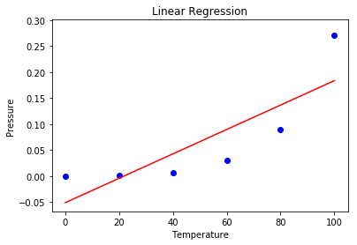
Step 6: Visualising the Polynomial Regression results using scatter plot.

# Visualising the Polynomial Regression results
plt.scatter(X, y, color = 'blue')

plt.plot(X, lin2.predict(poly.fit_transform(X)), color = 'red')
plt.title('Polynomial Regression')
plt.xlabel('Temperature')
plt.ylabel('Pressure')

plt.show()
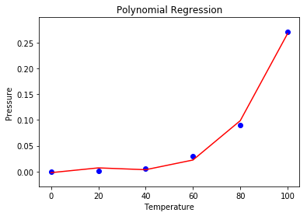
Step 7: Predicting new result with both Linear and Polynomial Regression.

# Predicting a new result with Linear Regression
lin.predict(110.0)
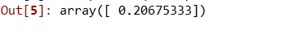
# Predicting a new result with Polynomial Regression
lin2.predict(poly.fit_transform(110.0))
